

Product Dissection for Blinkit

Company Overview:
Blinkit, formerly known as Grofers, is one of India’s leading quick-commerce platforms, revolutionizing the online grocery and essentials delivery market. Founded in 2013 by Albinder Dhindsa and Saurabh Kumar, the company focuses on delivering groceries, daily essentials, electronics, and other household products to customers within minutes. Acquired by Zomato in 2022, Blinkit has rapidly expanded its presence across major Indian cities through its network of dark stores and advanced delivery infrastructure. Known for its speed, convenience, and technology-driven operations, Blinkit has transformed urban shopping habits and emerged as a key player in India’s fast-growing quick-commerce industry.

Product Dissection and Real-World Problems Solved by Blinkit:
Blinkit has transformed the online grocery and quick-commerce industry by effectively addressing real-world challenges related to convenience, time management, and accessibility. With the increasing pace of urban lifestyles, consumers often struggle to manage daily grocery shopping alongside busy schedules. Blinkit solves this problem by enabling users to order groceries, household essentials, personal care products, electronics, and other daily needs through a seamless mobile application and receive deliveries within minutes. This rapid delivery model bridges the gap between traditional shopping and modern consumer expectations, providing a practical solution for instant access to essential products.
Blinkit’s innovative technology-driven platform has also revolutionized the customer shopping experience through features such as real-time order tracking, smart product recommendations, easy search functionality, and multiple payment options. By leveraging data analytics and customer behavior insights, Blinkit personalizes the shopping journey and ensures that users can quickly discover relevant products based on their preferences and purchase history. This effectively addresses the challenge of time-consuming shopping experiences and simplifies the process of finding and purchasing everyday essentials.
Furthermore, Blinkit’s extensive network of dark stores and efficient supply chain management has improved product availability and delivery efficiency in urban areas. The platform plays a significant role during emergencies and urgent situations by providing quick access to medicines, groceries, and daily necessities. Through its focus on speed, convenience, and customer satisfaction, Blinkit has reshaped consumer buying behavior and emerged as a leading quick-commerce platform in India. In conclusion, Blinkit’s product design successfully solves real-world problems by offering instant convenience, enhancing accessibility, and delivering a fast, reliable, and personalized shopping experience for modern consumers.

Case Study: Real-World Problems and Blinkit’s Innovative Solutions
Blinkit has transformed the online grocery and quick-commerce industry by solving real-world problems related to convenience, time management, and accessibility. With busy urban lifestyles, many consumers find traditional grocery shopping time-consuming and inconvenient. Blinkit addresses this issue by offering fast delivery of groceries, household essentials, and other daily needs within minutes through its mobile application.
The platform also improves the shopping experience through features such as real-time order tracking, personalized recommendations, and easy payment options. Its network of dark stores and efficient supply chain management ensures quick deliveries and better product availability. By combining technology, speed, and customer convenience, Blinkit has successfully reshaped modern shopping habits and become a leading quick-commerce platform in India.

Problem 1: Inconvenience and Time-Consuming Grocery Shopping
Real-World Challenge:
In today’s fast-paced urban lifestyle, consumers often struggle to find time for traditional grocery shopping. Long queues, traffic, limited store timings, and the effort required to purchase daily essentials create inconvenience for customers, especially working professionals and families.
Blinkit’s Solution:
Blinkit identified the growing demand for faster and more convenient shopping experiences. By offering instant delivery of groceries, household products, and daily essentials through its mobile application, Blinkit enables users to receive products within minutes. Features such as real-time order tracking, easy payment options, and a user-friendly interface simplify the shopping process. Through its quick-commerce model and efficient delivery network, Blinkit effectively solves the problem of time-consuming grocery shopping and enhances customer convenience.

Problem 2: Delayed Deliveries and Product Availability Issues
Real-World Challenge:
Customers often face delays in receiving essential products through traditional online grocery platforms. Limited product availability, long delivery times, and inefficient inventory management can create frustration, especially during urgent situations.
Blinkit’s Solution:
Blinkit solves this challenge through its network of dark stores and advanced supply chain management system. By storing products closer to customers and optimizing delivery routes, Blinkit ensures faster deliveries and improved product availability. The platform also uses data-driven recommendations and smart inventory tracking to provide a seamless and efficient shopping experience. This approach helps customers quickly access the products they need while reducing delivery delays and inconvenience.

Problem 3: Limited Access to Convenient and Reliable Shopping
Real-World Challenge:
Many consumers, especially working professionals, elderly individuals, and people with busy schedules, struggle to access groceries and daily essentials conveniently. Traditional shopping methods can be time-consuming and physically demanding, making reliable access to products a challenge.
Blinkit’s Solution:
Blinkit provides a convenient digital platform that allows users to order groceries, medicines, household items, and other essentials anytime through a mobile application. Its fast delivery service, user-friendly interface, and wide product range make shopping easier and more accessible for customers. Blinkit also creates opportunities for local sellers and delivery partners, contributing to employment generation and supporting the growing digital commerce ecosystem in India.

Problem 4: Difficulty in Managing Daily Needs Efficiently
Real-World Challenge:
Managing daily household needs can be difficult for consumers due to busy schedules, lack of time, and the inconvenience of visiting multiple stores for different products. Traditional shopping methods often reduce efficiency and consume significant time and effort.
Blinkit’s Solution:
Blinkit simplifies daily shopping by offering a single platform where users can quickly purchase groceries, household essentials, personal care items, electronics, and more. With features such as personalized recommendations, saved addresses, order history, and real-time tracking, Blinkit provides a smooth and efficient shopping experience. This technology-driven approach helps customers manage their daily needs conveniently while saving time and effort.

Problem 5: Traffic and Travel Inconvenience
Real-World Challenge:
Urban consumers spend significant time traveling to supermarkets due to traffic congestion and crowded stores.
Blinkit’s Solution:
By delivering products directly to customers’ doorsteps, Blinkit reduces unnecessary travel, saves time, and improves convenience for busy city residents.

Problem 6: Emergency Need for Essential Products
Real-World Challenge:
People often face urgent situations where they need groceries, medicines, baby products, or household items immediately, but nearby stores may be closed or far away.
Blinkit’s Solution:
Blinkit provides ultra-fast delivery within minutes, helping customers quickly access essential products during emergencies and unexpected situations.

Problem 7: Employment Opportunities
Real-World Challenge:
Growing urban populations require more flexible employment opportunities.
Blinkit’s Solution:
Blinkit generates jobs for delivery partners, warehouse staff, and operations teams, contributing to employment growth in the quick-commerce sector.

Conclusion:
Blinkit’s growth from an online grocery delivery platform to one of India’s leading quick-commerce companies highlights its ability to solve real-world consumer problems through innovation and technology. By addressing challenges such as time-consuming shopping, delayed deliveries, limited accessibility, and the need for convenience, Blinkit has transformed the way people purchase daily essentials. Through its fast delivery network, user-friendly platform, personalized shopping experience, and efficient supply chain management, Blinkit has successfully enhanced customer convenience and reshaped modern shopping habits. This case study demonstrates how Blinkit’s customer-focused approach and continuous innovation have established it as a major player in India’s rapidly evolving digital commerce industry.

Top Features of Blinkit
- User-Friendly Interface:
Blinkit offers a simple and easy-to-use mobile application that allows users to quickly browse products, search for items, and place orders conveniently.
- Quick Delivery Service:
One of Blinkit’s key features is its ultra-fast delivery system, which delivers groceries, household essentials, and other products within minutes.
- Wide Product Range:
Blinkit provides access to a variety of products including groceries, fruits, vegetables, dairy products, snacks, personal care items, electronics, medicines, and household essentials.
- Real-Time Order Tracking:
Users can track their orders live through the app, allowing them to monitor delivery progress and estimated arrival times.
- Personalized Recommendations:
Blinkit uses customer preferences and purchase history to recommend relevant products, improving the shopping experience.
- Multiple Payment Options:
The platform supports various payment methods such as UPI, debit cards, credit cards, wallets, and cash on delivery for customer convenience.
- Offers and Discounts:
Blinkit regularly provides discounts, combo offers, and promotional deals that help users save money while shopping.
- Dark Store Network:
Blinkit operates through strategically located dark stores that help manage inventory efficiently and ensure faster deliveries.
- Easy Search and Categories:
Products are organized into categories with a smart search feature, making it easier for users to find products quickly.
- 24/7 Convenience:
Blinkit allows users to shop anytime from anywhere, reducing the need to visit physical stores and making daily shopping more convenient.

Schema Description:
The schema for Blinkit involves multiple entities that represent different aspects of the platform. These entities include Users, Products, Orders, Delivery Partners, Payments, Categories, and more. Each entity contains attributes that define its properties and relationships with other entities.

User Entity:
Users are the primary customers using the Blinkit platform.
- UserID (Primary Key): A unique identifier for each user.
- Full_Name: The user’s full name.
- Email: The user’s email address.
- Phone_Number: Contact number of the user.
- Address: Delivery address of the user.
- Registration_Date: The date when the user registered on Blinkit.

Product Entity:
Products represent the items available for purchase on Blinkit.
- ProductID (Primary Key): A unique identifier for each product.
- Product_Name: Name of the product.
- CategoryID : Category of the product.
- Price: Cost of the product.
- Stock Quantity: Available quantity in inventory.
- Brand: Brand name of the product.

Category Entity:
Categories help organize products into groups.
- CategoryID (Primary Key): A unique identifier for each category.
- Category Name: Name of the category (e.g., Groceries, Dairy, Snacks).

Order Entity:
Orders contain details of customer purchases.
- OrderID (Primary Key): A unique identifier for each order.
- UserID : Customer who placed the order.
- Order Date: Date and time of the order.
- Total Amount: Total cost of the order.
- Order Status: Current status of the order (Delivered, Pending, Cancelled).

OrderDetails Entity:
Stores detailed information about products included in an order.
- OrderDetailsID (Primary Key): Unique identifier for each order detail.
- OrderID : Related order.
- ProductID : Product included in the order.
- Quantity: Quantity of the product ordered.
- Subtotal: Total price for the selected quantity.

Payment Entity:
Payments store transaction-related information.
- PaymentID (Primary Key): A unique identifier for each payment.
- OrderID : Related order.
- Payment Method: Payment type (UPI, Card, Wallet, COD).
- Payment Status: Status of the payment.
- Payment Date: Date of payment transaction.

Delivery Partner Entity:
Delivery partners handle the order deliveries.
- DeliveryPartnerID (Primary Key): Unique identifier for each delivery partner.
- Name: Delivery partner’s name.
- Phone Number: Contact number of the delivery partner.
- Vehicle Type: Type of vehicle used for delivery.

Delivery Entity:
Tracks delivery information for orders.
- DeliveryID (Primary Key): Unique identifier for each delivery.
- OrderID : Related order.
- DeliveryPartnerID : Assigned delivery partner.
- Delivery_Status: Status of delivery.
- Delivery_Time: Estimated or completed delivery time.

Relationships:
- Users place Orders – Each user can place multiple orders, while each order belongs to one user.
- Orders contain Products – Each order can contain multiple products, and each product can appear in multiple orders.
- Products belong to Categories – Each product belongs to one category, while each category can contain multiple products.
- Users make Payments for Orders – Each order is associated with one payment, and users can make multiple payments for different orders.
- Delivery Partners deliver Orders – Each delivery partner can deliver multiple orders, while each order is assigned to one delivery partner.
- Users receive Deliveries – Users can receive multiple deliveries linked to their orders.
- Products are managed through Inventory – Each product has stock information that helps manage availability and quick delivery.
- Users search and purchase Products – Users can browse, search, and purchase multiple products through the platform.

ER Diagram:
Let’s construct an ER diagram that clearly represents the relationships and attributes of the entities within the Blinkit schema. This ER diagram acts as a visual representation of Blinkit’s data model, helping to understand how different components of the platform interact with each other. The diagram highlights key entities such as Users, Products, Orders, Payments, Categories, and Delivery Partners along with their relationships. By using this ER diagram, one can better understand the flow of data, order management process, product handling, and delivery operations that power Blinkit’s quick-commerce platform.

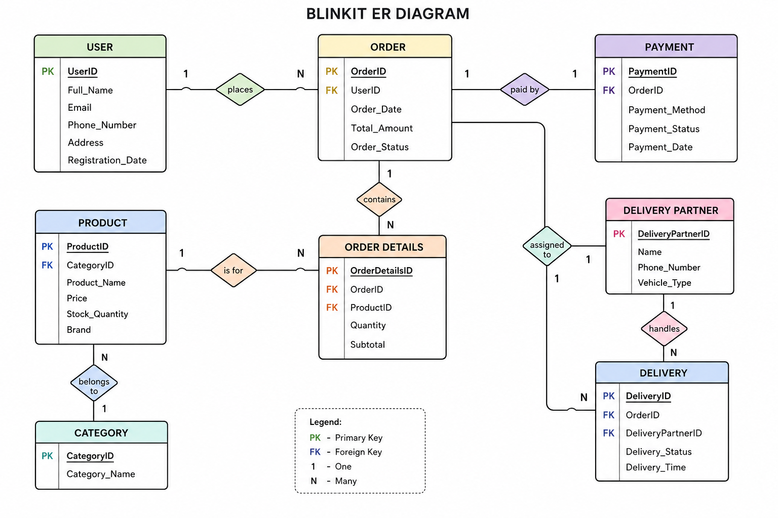

Conclusion
In this case study, we explored the schema design and Entity-Relationship (ER) diagram of Blinkit. Blinkit has transformed the quick-commerce industry by providing fast and convenient delivery of groceries and daily essentials, making shopping easier for modern consumers. The platform’s structured data model, consisting of entities such as users, products, orders, payments, categories, delivery partners, and deliveries, forms the backbone of its efficient operations. By understanding this schema and ER diagram, we gain insight into how Blinkit manages customer orders, inventory, payments, and delivery processes seamlessly. This efficient database structure supports Blinkit’s ability to provide a smooth user experience, rapid deliveries, and reliable service, contributing to its growing success in India’s digital commerce market.

